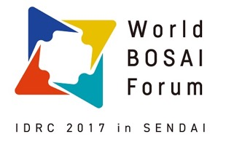 

***4th***

**ACUDR**

**4th ASIAN CONFERENCE**

**ON URBAN DISASTER REDUCTION**

**26-28 November 2017**

**Sendai,**

**Japan**

**Organized by:**

**Institute of Social Safety Science (ISSS),**

**Co-organized by**

**International Research Institute of Disaster Science (IRIDeS),**

**Tohoku University**

 　kosham.eps 

* **INTRODUCTION**

Organized by I Institute of Social Safety Science (ISSS), Asian Conference on Urban Disaster Reduction (ACUDR) started in 2012 in order to widely exchange academic and social information on urban disaster risk reduction in Asia among related academic societies in the countries. The first ACUDR was held in Iwaki City, Fukushima, Japan, in August 2012, not only to share research outcome but also to understand recovery conditions of the city seriously affected by the 2011 Great East Japan Earthquake and Tsunami, and a fruitful discussion took place among members of the Korean Society of Hazard Mitigation (KOSHAM), the Disaster Management Society of Taiwan (DMST), and ISSS based on the Trilateral Agreement of Cooperation. Since then, two ACUDRs were held in Taipei, Taiwan, in November 2014 and in Goyan, Korea, in November 2015.

With the co-organizer, International Research Institute of Disaster Science (IRIDeS) at Tohoku University, ISSS is organizing the 4th ACUDR during November 26-28, 2017 in Sendai, Japan, as a side event of International Disaster and Risk Conference 2017 “World Bosai Forum.” It will be a good opportunity to see current conditions of the coastal areas affected by the 2011 Great East Japan Earthquake as well as sharing informative research outcomes presented by members of KOSHAM, DMST, and ISSS.

* **HISTORY OF ACUDR**

2015 Goyang, Korea

2014 Taipei, Taiwan

2012 Iwaki, Japan

* **IMPORTANT DATES & PROCEDURE (revised as of 17 August 2017)**

Submission of ABSTRACT: **31 July 2017.** **Extended to 10 August, Secondly extended to 25 August.**

Notification of Acceptance: **7 August 2017. Extended to 17 August, Secondly extended to 25 August.**

Submission of FULL PAPER: **31 August 2017. Extended to 15 September 2017**

Last day of Early Registration: **31 August 2017. Extended to 28 September 2017**

Authors are invited to submit abstract of one page to the secretary by the due date shown above via email to: **acudr@isss.info**. Submissions must include the following contents: Authors name, Affiliated organization, Prefix, Email address, Position, Subject number, Paper title, and Abstract with purpose and major results clearly stated within 300-400 words. A specialized session on risk communication will be organized in the afternoon of 27 November. Interested authors are encouraged to submit relevant abstracts. Abstract must follow the Template of One-Page Abstract format. Authors whose abstract were accepted must submit their full paper to the secretary by the due date shown above via e-mail to: [**acudr@isss.info**](mailto:acudr@isss.info). Full paper must follow the Template of Full Papers format.

All speakers must make payment by 28 September 2017 through 'Registration for ACUDR participants' in the World Bosai Forum registration site to have their accepted papers included in the proceedings and scheduled for presentation. Co-authors participating in 4ACUDR are strongly encouraged to register before 28 September to take advantage of the reduced rate for 4ACUDR participants to the World Bosai Forum.

* **REGISTRATION FEE**

Delegates:

JPY 22,000 (Early registration on and before 28 September)

JPY 27,000 (after 28 September)

Students:

JPY 11,000 (Early registration on and before 28 September)

JPY 13,000 (after 28 September)

The registration fee includes one symposium USB proceedings and one reception dinner.

* **SYMPOSIUM VENUE**

Sendai International Center, Aobayama, Aoba-ku, Sendai 980-0856, Japan

International Research Institute of Disaster Science, Tohoku University, Aramaki Aza-Aoba 468-1, Aoba-ku, Sendai 980-0845, Japan

* **PARTICIPATION IN WORLD BOSAI FORUM**

The 4th ACUDR will be held as a side event of the World Bosai Forum: http://www.worldbosaiforum.com/english/

The registrants of the 4th ACUDR can participate in sessions, special programs, and other activities, including the opening ceremony prepared for the World Bosai Forum.

We would like all participants to spend fruitful time in the events as well as the 4th ACUDR.

* **TECHNICAL TOUR**

ISSS will organize a one-day tour to see current recovery and reconstruction conditions of coastal areas affected by the 2011 Great East Japan Earthquake and Tsunami. Visitors will have the opportunity to visit new urban facilities, parks, and communities.

* **ABOUT SENDAI CITY**

Sendai is a city with a population of one million, and is the political and economic center of Japan’s Tohoku(northeast)Region. Although Sendai is a large city, it is known throughout Japan as a modern city in harmony with nature. The city possesses beautiful scenery, such as the Hirose-gawa River that runs through central Sendai, and the lush zelkova trees that line its streets. Greenery is especially abundant in the center of the city, which has tree-lined streets and parks. As a result, Sendai is called the “City of Trees.”

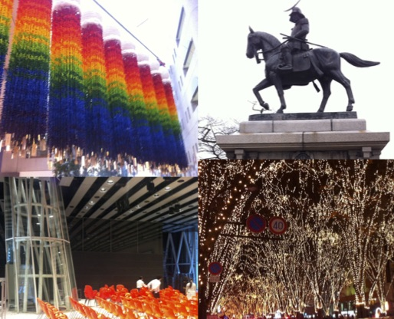

* **ISSS INTERNATIONAL EXCHANGE COMMITTEE**

**Organizer**

**Dr. Satoru Nishikawa** Executive Director of Research, Japan Center for Area Development Research (JCADR)

**Members**

**Prof. Kimiro Meguro** Director, ICUS, IIS, UTokyo, Japan

**Prof. Shigeo Tatsuki** Professor, Department of Sociology, Doshisya University, Japan

**Prof. Osamu Murao** Professor, IRIDeS, Tohoku University, Japan

**Prof. Shinichiro Mori** Associate Professor, Faculty of Engineering, Ehime University, Japan

**Dr. Anna Matsukawa** Disaster Reduction and Human Renovation Institution, Japan

* **CONTACT**

Prof. Osamu Murao

Email: murao@irides.tohoku.ac.jp

Website: [**http://isss.jp.net/4acudr/**](http://isdm.lab.irides.tohoku.ac.jp/USMCA2017/)

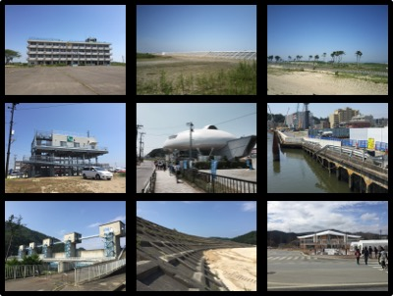

Current Recovery Conditions from 2011 Great East Japan Earthquake